**DAILY ONLINE ACTIVITIES SUMMARY**

|  |  |  |  |  |  |  |  |
| --- | --- | --- | --- | --- | --- | --- | --- |
| **Date:** | **11/06/2020** | | | | **Name:** | **Anusha. K** | |
| **Sem & Sec** | **4th SEM 'A' Section** | | | | **USN:** | **4AL18CS009** | |
| **Online Test Summary** | | | | | | | |
| **Subject** | | **No test** | | | | | |
| **Max. Marks** | | **-** | | **Score** | | **-** | |
| **Certification Course Summary** | | | | | | | |
| **Course** | **Introduction to advanced spark** | | | | | | |
| **Certificate Provider** | | | **greatlearning academy** | **Duration** | | | **1.5 hours** |
| **Coding Challenges** | | | | | | | |
| **Problem statement 1:**  Write a Java Program to Segregate Even and Odd numbers | | | | | | | |
| **Status: completed** | | | | | | | |
| **Uploaded the report in Github** | | | | **yes** | | | |
| **If yes Repository name** | | | | [**https://github.com/anusha20219/Lockdown-coding**](https://github.com/anusha20219/Lockdown-coding) | | | |
| **Uploaded the report in slack** | | | | **yes** | | | |

ONLINE TEST DETAILS: No test

CERTIFICATION COURSE DETAILS: Today I began with machine learning foundations and then started introduction to advanced spark certification course. The topics studied are spark properties, garbage collection, Data serialization, memory tuning, job scheduling,application schedule and then attend the quiz and got certificate.

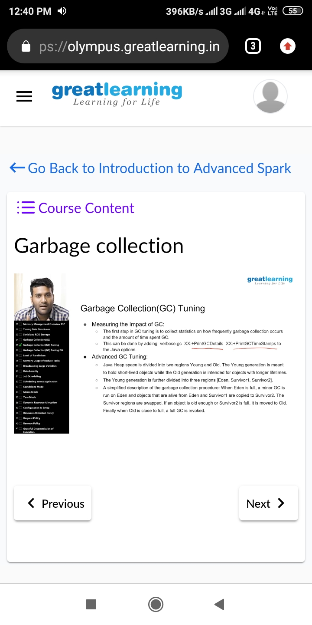

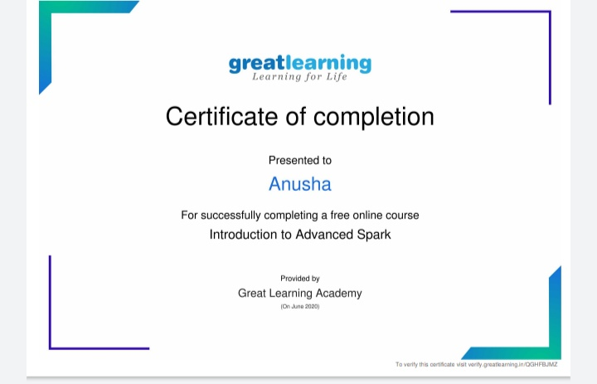

Coding challenge details:

Problem statement 01:Write a Java Program to Segregate Even and Odd numbers

